**ABR - Error in Processing**  
  
ROME IE# 243479551

Oppty: 1-88AMES9

Product - Voice LD

ABN Express ABR: 1-88J8720 - Accepted - Error in Processing

SR Details Row# 1-88J60QW

ABN71519-E563489

FMO356348918032

ls -ltr *1-88J8720*

ls -ltr *1-88J60QW*

-rw-rw---- 1 sadmin siebel 1505 Mar 29 11:03 Request_CreateSolutionCr_EFMS1-88J60QW.xml

-rw-rw---- 1 sadmin siebel 459 Mar 29 11:04 Response_CreateSolutionCr_EFMS1-88J60QW.xml

http://zlpv6973.vci.att.com:2200/wxml/Request_CreateSolutionCr_EFMS1-88J60QW.xml

http://zlpv6973.vci.att.com:2200/wxml/Response_CreateSolutionCr_EFMS1-88J60QW.xml

SolutionNumber="FMO356348918032

ROME Analysis:

User tried submitting an ABR on Mar 29 11:03

<http://zlpv6973.vci.att.com:2200/wxml/Request_CreateSolutionCr_EFMS1-88J60QW.xml>

<http://zlpv6973.vci.att.com:2200/wxml/Response_CreateSolutionCr_EFMS1-88J60QW.xml>

Digambar Ghanshyam Mahajan(10:50:08 PM): I could see we have got an error from EFMS

Digambar Ghanshyam Mahajan(10:50:18 PM):

[ns3:ABSCIFErrorCode]9001[/ns3:ABSCIFErrorCode]

[ns3:ABSCIFErrorDesc]Sub Account Tax Address : Zip Code passed is Invalid.[/ns3:ABSCIFErrorDesc]

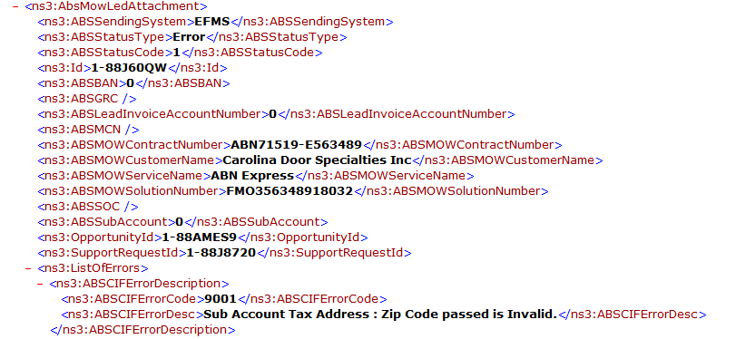

Digambar Ghanshyam Mahajan(10:50:33 PM):

<http://zlpv7047.vci.att.com:2220/RWS_out/UpdateeCRMOpportunityService/20180329_110601_0_9998_SBLReq.xml>

<http://zlpv7047.vci.att.com:2220/RWS_out/UpdateeCRMOpportunityService/20180329_110601_0_9998_SBLResp.xml>

Digambar Ghanshyam Mahajan(10:51:33 PM): EFMS needs to tell why they are giving this error

-----------------------------------------------------**********************----------------------------------------

ROME IE#243865419

Opty ID:1-85CNY49

AVPN ABR: 1-85E2VAW - Accepted - Error in Processing

SR Details Row# 1-85E2VB5

FMO355820718030

NBI3558207 - Addendum

NBI06528

ls -ltr *1-85E2VAW*

-rw-rw---- 1 sadmin siebel 2237 Apr 10 13:44 ABSArBrMowSetContractGroup_Request_1-85E2VAW.xml

-rw-rw---- 1 sadmin siebel 360 Apr 10 13:44 ABSArBrMowSetContractGroup_Response1-85E2VAW.xml

-rw-rw---- 1 sadmin siebel 47308 Apr 10 13:44 ARBR_SetBillPkgQuery1-85E2VAW.xml

-rw-rw---- 1 sadmin siebel 3951 Apr 10 13:44 ARBRMOW_SetBillPkgRequest_1-85E2VAW.xml

-rw-rw---- 1 sadmin siebel 3558 Apr 10 13:44 ARBRMOW_SetBillPkgReqt1-85E2VAW.xml

-rw-rw---- 1 sadmin siebel 1275 Apr 10 13:44 ARBRMOW_SetBillPkgResponse_1-85E2VAW.xml

-rw-rw---- 1 sadmin siebel 1355 Apr 10 13:44 ARBR_MOW_Request_CreateSolutionCr_EFMS_1-85E2VAW.xml

-rw-rw---- 1 sadmin siebel 459 Apr 10 13:44 ARBR_MOW_Response_CreateSolutionCr_EFMS_1-85E2VAW.xml

-rw-rw---- 1 sadmin siebel 557 Apr 10 13:46 ARBRMOW_getBillAcntPkg_Req1-85E2VAW.xml

-rw-rw---- 1 sadmin siebel 37824 Apr 10 13:46 ARBRMOW_getBillPkg_Resp1-85E2VAW.xml

<http://zlpv6973.vci.att.com:2200/wxml/ARBR_MOW_Request_CreateSolutionCr_EFMS_1-85E2VAW.xml>

<http://zlpv6973.vci.att.com:2200/wxml/ARBR_MOW_Response_CreateSolutionCr_EFMS_1-85E2VAW.xml>

SolutionNumber="FMO355820718030

findit ManageEnterpriseSalesBillAccountDetails/SetBillAccountpackage FMO355820718030 90

<http://zlpv7047.vci.att.com:2220/RWS_out/ManageEnterpriseSalesBillAccountDetails/SetBillAccountpackage/20180410_134416_9920_DSL_req.xml>

<http://zlpv7047.vci.att.com:2220/RWS_out/ManageEnterpriseSalesBillAccountDetails/SetBillAccountpackage/20180410_134416_NBI3558207_4745_CSI_req.xml>

findit UpdateeCRMOpportunityService FMO355820718030 90

<http://zlpv7059.vci.att.com:2220/RWS_out/UpdateeCRMOpportunityService/20180410_134637_EMPTY_5628_Req.xml>

<http://zlpv7059.vci.att.com:2220/RWS_out/UpdateeCRMOpportunityService/20180410_134638__6764_SBLReq.xml>

findit BillAccountQuery/getBillAccountHierarchy FMO355820718030 90

<http://zlpv7059.vci.att.com:2220/RWS_out/BillAccountQuery/getBillAccountHierarchy/20180410_134641_5560_DSLReq.xml>

<http://zlpv7059.vci.att.com:2220/RWS_out/BillAccountQuery/getBillAccountHierarchy/20180410_134641_5560_DSLResp.xml>

<http://zlpv7059.vci.att.com:2220/RWS_out/BillAccountQuery/getBillAccountHierarchy/20180410_134641_0260_GCPReq.xml>

<http://zlpv7059.vci.att.com:2220/RWS_out/BillAccountQuery/getBillAccountHierarchy/20180410_134641_0260_GCPResp.xml>

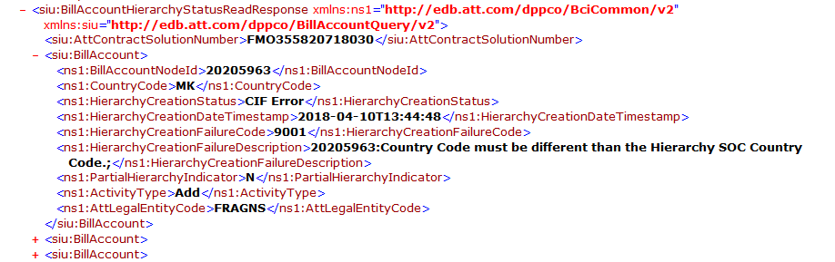

---------------------------------------------------*******************----------------------------------------------------

ROME IE#244000477

Customer: PRESIDENTE SUPERMARKET INC

Oppty ID: 1-89NFFIE

SR ID: 1-89X3DNZ

Issue:

For opty 1-89NFFIE, the ABR did not complete.

Oppty ID: 1-89NFFIE - VVB Express - Growth

ABN Express ABR: 1-89X3DNZ - Accepted - Plan Subscription Requested

SR Details Row# 1-89X7JF8

VVB71515-V137623 - Addendum

ATT Contract Solution# 1-89X7JF8

ls -ltr *1-89X7JF8*

-rw-rw---- 1 sadmin siebel 1428 Mar 28 09:38 Request_CreateSolutionCr_EFMS1-89X7JF8.xml

-rw-rw---- 1 sadmin siebel 459 Mar 28 09:38 Response_CreateSolutionCr_EFMS1-89X7JF8.xml

<http://zlpv6973.vci.att.com:2200/wxml/Request_CreateSolutionCr_EFMS1-89X7JF8.xml>

<http://zlpv6973.vci.att.com:2200/wxml/Response_CreateSolutionCr_EFMS1-89X7JF8.xml>

findit UpdateeCRMOpportunityService 1-89X7JF8 90

<http://zlpv7059.vci.att.com:2220/RWS_out/UpdateeCRMOpportunityService/20180417_155742_EMPTY_8834_Req.xml>

<http://zlpv7059.vci.att.com:2220/RWS_out/UpdateeCRMOpportunityService/20180417_155744_0_0587_SBLReq.xml>

<http://zlpv7059.vci.att.com:2220/RWS_out/UpdateeCRMOpportunityService/20180417_155744_0_0587_SBLResp.xml>

-----------------------------------------*********************-----------------------------------------------------

ROME IE# 244228059

Oppty: 1-85KYRFS - Collaborate

HCMS ABR: 1-8626OGX was having CIF error

SR Details Row# 1-861Z8M3

findit UpdateeCRMOpportunityService ASP355883818030 90

<http://zlpv7046.vci.att.com:2220/RWS_out/UpdateeCRMOpportunityService/20180419_174203__2692_SBLReq.xml>

<http://zlpv7046.vci.att.com:2220/RWS_out/UpdateeCRMOpportunityService/20180419_174203__2692_SBLResp.xml>

<ABSSendingSystem>**EFMS**</ABSSendingSystem>

<ABSStatusType>**Error**</ABSStatusType>

findit BillAccountQuery/getBillAccountHierarchy ASP355883818030 90

<http://zlpv7047.vci.att.com:2220/RWS_out/BillAccountQuery/getBillAccountHierarchy/20180419_174204_8186_DSLReq.xml>

<http://zlpv7047.vci.att.com:2220/RWS_out/BillAccountQuery/getBillAccountHierarchy/20180419_174204_8186_DSLResp.xml>

<http://zlpv7047.vci.att.com:2220/RWS_out/BillAccountQuery/getBillAccountHierarchy/2018>0419_174205_7378_GCPReq.xml

<http://zlpv7047.vci.att.com:2220/RWS_out/BillAccountQuery/getBillAccountHierarchy/20180419_174205_7378_GCPResp.xml>

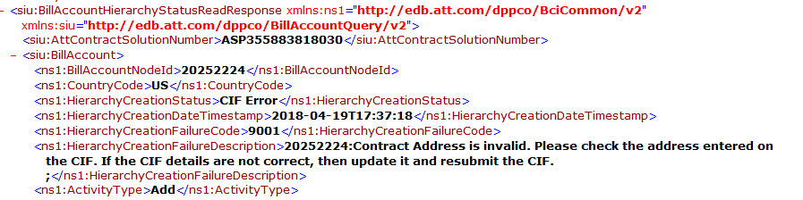

Contract address on ABR was

ATTN: MARTIN MOORE

MORGANTOWN

26505

So we had advised user to correct the Contract Address and submit ABR SR.

User updated it and submitted an ABR

ls -ltr *1-8626OGX*

-rw-rw---- 1 sadmin siebel 2155 Apr 20 09:30 ABSArBrMowSetContractGroup_Request_1-8626OGX.xml

-rw-rw---- 1 sadmin siebel 360 Apr 20 09:30 ABSArBrMowSetContractGroup_Response1-8626OGX.xml

-rw-rw---- 1 sadmin siebel 16910 Apr 20 09:30 ARBR_SetBillPkgQuery1-8626OGX.xml

-rw-rw---- 1 sadmin siebel 3751 Apr 20 09:30 ARBRMOW_SetBillPkgRequest_1-8626OGX.xml

-rw-rw---- 1 sadmin siebel 3359 Apr 20 09:30 ARBRMOW_SetBillPkgReqt1-8626OGX.xml

-rw-rw---- 1 sadmin siebel 1232 Apr 20 09:30 ARBRMOW_SetBillPkgResponse_1-8626OGX.xml

-rw-rw---- 1 sadmin siebel 1089 Apr 20 09:30 ARBR_MOW_Request_CreateSolutionCr_EFMS_1-8626OGX.xml

-rw-rw---- 1 sadmin siebel 459 Apr 20 09:31 ARBR_MOW_Response_CreateSolutionCr_EFMS_1-8626OGX.xml

-rw-rw---- 1 sadmin siebel 557 Apr 20 09:49 ARBRMOW_getBillAcntPkg_Req1-8626OGX.xml

-rw-rw---- 1 sadmin siebel 9506 Apr 20 09:49 ARBRMOW_getBillPkg_Resp1-8626OGX.xml

<http://zlpv6973.vci.att.com:2200/wxml/ARBR_MOW_Request_CreateSolutionCr_EFMS_1-8626OGX.xml>

<http://zlpv6973.vci.att.com:2200/wxml/ARBR_MOW_Response_CreateSolutionCr_EFMS_1-8626OGX.xml>

SolutionNumber="ASP355883818030

findit UpdateeCRMOpportunityService ASP355883818030 90

<http://zlpv7047.vci.att.com:2220/RWS_out/UpdateeCRMOpportunityService/20180420_094919_EMPTY_9613_Req.xml>

<http://zlpv7047.vci.att.com:2220/RWS_out/UpdateeCRMOpportunityService/20180420_094920_0_7029_SBLReq.xml>

<http://zlpv7047.vci.att.com:2220/RWS_out/UpdateeCRMOpportunityService/20180420_094920_0_7029_SBLResp.xml>

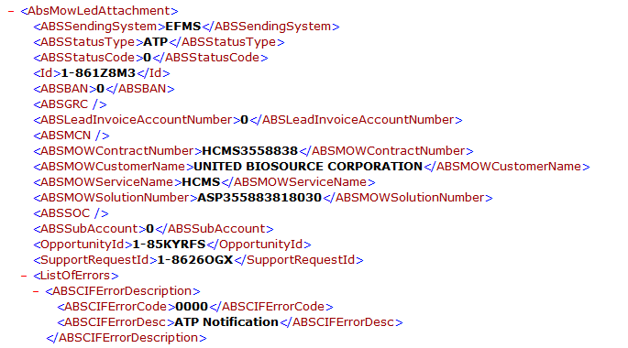

<http://zlpv7047.vci.att.com:2220/RWS_out/BillAccountQuery/getBillAccountHierarchy/20180420_094921_8749_DSLReq.xml>

<http://zlpv7047.vci.att.com:2220/RWS_out/BillAccountQuery/getBillAccountHierarchy/20180420_094921_8749_DSLResp.xml>

<http://zlpv7047.vci.att.com:2220/RWS_out/BillAccountQuery/getBillAccountHierarchy/20180420_094921_5137_GCPReq.xml>

<http://zlpv7047.vci.att.com:2220/RWS_out/BillAccountQuery/getBillAccountHierarchy/20180420_094921_5137_GCPResp.xml>

